**Project Report On**

*Fake News Prediction*

**Submitted in fulfilment of the degree** of

Department of Information Technology

***BY***

***NAME:-***

**Sirshendhu Ghosh (11900220001)**

**Dipesh Das (11900220012)**

**Atul Krishna Gupta (11900220019)**

**Susanta Dey (11900220024)**

**Tamosa Mondal (11900220033)**

**Soumili Rooj (11900220034)**

**Rohan Barick (11900220037)**

**Mustafijur Rahaman (11900220038)**

***DEPARTMENT OF IT***

I hereby forward the documentation prepared under my supervision by SIRSHENDHU GHOSH, DIPESH DAS, ATUL KRISHNA GUPTA, SUSANTA DEY, TAMOSA MONDAL, SOUMILI ROOJ,

ROHAN BARICK(TL), MUSTAFIJUR RAHAMAN entitled SILIGURI INSTITUTE OF TECHNOLOGY be accepted as fulfilment of the requirement for the Degree of B. TECH in INFORMATION TECHNOLOGY from SILIGURI INSTITUTE OF TECHNOLOGY affiliated to Maulana Abul Kalam Azad University of Technology (MAKAUT).

By

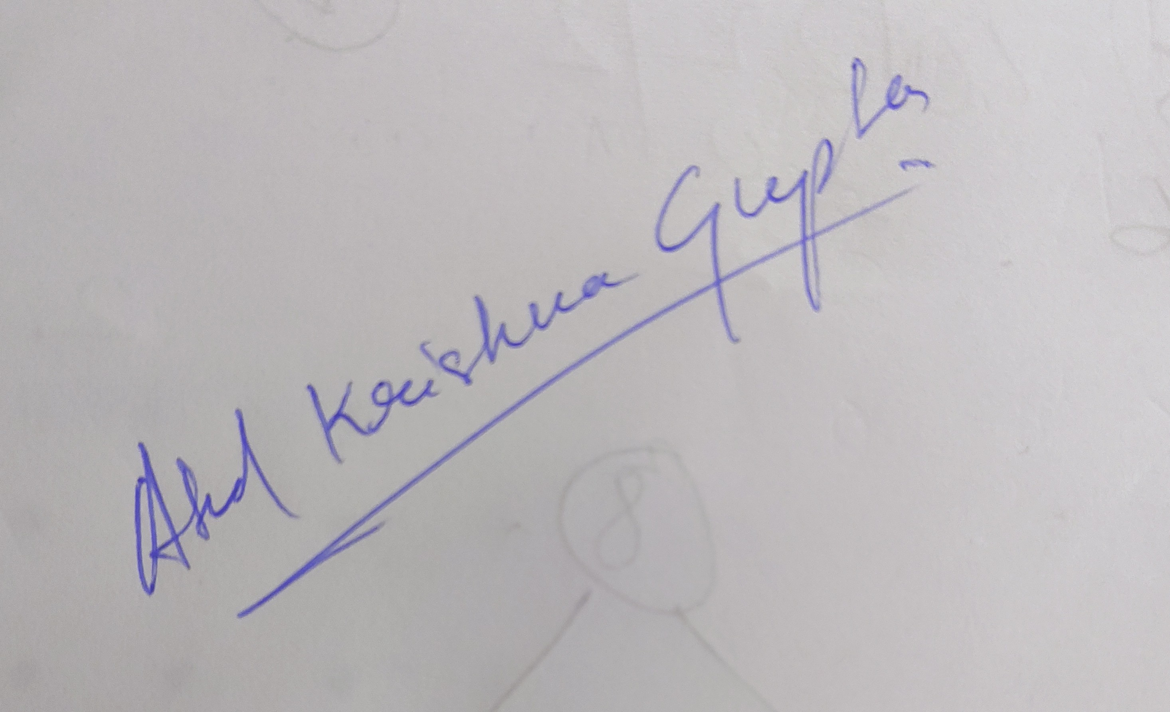

ATUL KRISHNA GUPTA,

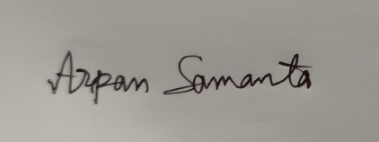

Mr. ARPAN SHAMANTA

Project Guide

Ltd: Sikharthy Infotech pvt.ltd

